

说明: 说明: 封面网址.emf

ISCOM2608G (B) Series

()



Raisecom Technology Co., Ltd. provides customers with comprehensive technical support and services. For any assistance, please contact our local office or company headquarters.

Website: http://www.raisecom.com

Tel: 8610-82883305

Fax: 8610-82883056

Email: export@raisecom.com

Address: Raisecom Building, No. 11, East Area, No. 10 Block, East Xibeiwang Road, Haidian District, Beijing, P.R.China

Postal code: 100094

-----------------------------------------------------------------------------------------------------------------------------------------

Notice

Copyright ©**2022**

Raisecom

All rights reserved.

No part of this publication may be excerpted, reproduced, translated, or utilized in any form or by any means, electronic or mechanical, including photocopying and microfilm, without permission in Writing from **Raisecom Technology Co., Ltd.**

说明: 说明: RAISECOM is the trademark of Raisecom Technology Co., Ltd.

All other trademarks and trade names mentioned in this document are the property of their respective holders.

The information in this document is subject to change without notice. Every effort has been made in the preparation of this document to ensure accuracy of the contents, but all statements, information, and recommendations in this document do not constitute a warranty of any kind, express or implied.

Preface

Objectives

This document describes the ISCOM2608G series switch in terms of product overview, networking applications, system structure, device installation, and technical specifications.

The appendix describes cables and SFP modules, and lists terms, acronyms, and abbreviations involved in this document.

Versions

The following table lists the product versions related to this document.

| Product name | Hardware version | Software version |
| --- | --- | --- |
| ISCOM2608G-2GE-AC | B | V3.63M |
| ISCOM2608G-2GE-DC | B | V3.63M |
| ISCOM2608G-2GE-PWR-AC | B | V3.63M |
| ISCOM2608G-2GE-PWR-DC | B | V3.63M |

Conventions

Symbol conventions

The symbols that may be found in this document are defined as below.

| Symbol | Description |
| --- | --- |
| 说明: Warning.png | Indicate a hazard with a medium or low level of risk which, if not avoided, could result in minor or moderate injury. |
| 说明: Caution.png | Indicate a potentially hazardous situation that, if not avoided, could cause equipment damage, data loss, and performance degradation, or unexpected results. |
| 说明: Note.png | Provide additional information to emphasize or supplement important points of the main text. |
| 说明: Tip.png | Indicate a tip that may help you solve a problem or save time. |

General conventions

| Convention | Description |
| --- | --- |
| Times New Roman | Normal paragraphs are in Times New Roman. |
| Arial | Paragraphs in Warning, Caution, Notes, and Tip are in Arial. |
| **Boldface** | Buttons and navigation paths are in **Boldface**. |
| *Italic* | Book titles are in *italics*. |
| Lucida Console | Terminal display is in Lucida Console. |
| Book Antiqua | Heading 1, Heading 2, Heading 3, and Block are in Book Antiqua. |

Change history

Updates between document versions are cumulative. Therefore, the latest document version contains all updates made to previous versions.

Issue 03 (2022-09-14)

* Third commercial release
* Upgraded the software version to V3.63M.

Issue 02 (2022-06-24)

* Second commercial release
* Added the ISCOM2608G-2GE-PWR.

Issue 01 (2022-05-25)

Initial commercial release

Contents

1 Overview 1

1.1 Introduction 1

1.2 Features 1

1.3 Ordering information 3

1.3.1 Naming convention 3

1.3.2 Ordering information about device 4

1.3.3 Ordering information about auxiliary parts 5

2 Networking applications 12

2.1 Enterprise park network access 12

2.2 Residential area broadband access 13

3 System structure 15

3.1 Panels 15

3.1.1 Front panels 15

3.1.2 Rear panels 17

3.2 Interfaces 17

3.2.1 Service interfaces 18

3.2.2 Management interfaces 19

3.3 Power interfaces 20

3.3.1 DC power 20

3.3.2 AC power interface 20

3.4 LEDs 21

3.4.1 ISCOM2608G-2GE 21

3.4.2 ISCOM2608G-2GE-PWR 22

4 Device installation 23

4.1 Installing hardware 23

4.1.1 Preparing for installation 23

4.1.2 Installing device 24

4.1.3 Connecting cables 28

4.2 Installing software 31

5 Technical specifications 32

5.1 Overall parameters 32

5.2 Laser safety class 33

5.3 Reliability specifications 34

5.4 EMC specifications 34

5.5 Safety standards 34

5.6 Environmental requirements 34

5.6.1 Storage environment 35

5.6.2 Transport environment 36

5.6.3 Operation environment 36

5.7 Standards and protocols 37

6 Appendix 39

6.1 Cables 39

6.1.1 Fiber 39

6.1.2 Ethernet cable 41

6.1.3 Ground cable 44

6.1.4 DC power cable 45

6.1.5 AC power cable 46

6.1.6 RJ45 Console cable 48

6.2 Terms 50

6.3 Acronyms and abbreviations 52

Figures

Figure 1-1 Naming convention 4

Figure 2-1 Enterprise park network access networking 13

Figure 2-2 Residential area broadband access networking 14

Figure 3-1 Front panel of ISCOM2608G-2GE-AC 15

Figure 3-2 Front panel of ISCOM2608G-2GE-DC 16

Figure 3-3 Front panel of ISCOM2608G-2GE-PWR-AC 16

Figure 3-4 Front panel of ISCOM2608G-2GE-PWR-DC 17

Figure 3-5 Rear panel of ISCOM2608G-2GE-AC/DC 17

Figure 3-6 Rear panel of ISCOM2608G-2GE-PWR-AC/DC 17

Figure 3-7 DC power interface 20

Figure 3-8 AC power interface 21

Figure 4-1 Installing brackets 25

Figure 4-2 Installing cage nuts 25

Figure 4-3 Installing guide rails 26

Figure 4-4 Installing device horizontally in rack 26

Figure 4-5 Installing wall-mount brackets 27

Figure 4-6 Installing screws 27

Figure 4-7 Wall-mount installation 28

Figure 4-8 Inserting SFP optical module 28

Figure 4-9 Connecting fiber 29

Figure 4-10 Connecting Ethernet cable 29

Figure 4-11 Connecting ground cable 30

Figure 4-12 Connecting AC power cable 30

Figure 4-13 Connecting DC power cable 31

Figure 6-1 LC/PC fiber connector 40

Figure 6-2 Ethernet cable 41

Figure 6-3 Wiring of 10/100/1000 Mbit/s straight-through cable 42

Figure 6-4 Wiring of 100 Mbit/s crossover cable 43

Figure 6-5 Wiring of 1000 Mbit/s crossover cable 43

Figure 6-6 Ground cable 44

Figure 6-7 OT terminal 44

Figure 6-8 DC power cable 45

Figure 6-9 European AC power cable 47

Figure 6-10 American AC power cable 47

Figure 6-11 RJ45 Console cable 48

Figure 6-12 Wiring between DB9 female connector and RJ45 Console interface 49

Tables

Table 1-1 Features 1

Table 1-2 Naming convention 4

Table 1-3 Ordering information about device 4

Table 1-4 Ordering information about non-PoE model accessories 5

Table 1-5 Ordering information about PoE model accessories 5

Table 1-6 Ordering information about non-PoE model wall-mount accessories 6

Table 1-7 Ordering information about PoE model wall-mount accessories 6

Table 1-8 Ordering information about 100 Mbit/s SFP optical module 6

Table 1-9 Ordering information about 100 Mbit/s SFP electrical module 7

Table 1-10 Ordering information about 1000 Mbit/s SFP optical module 8

Table 3-1 Service interfaces 18

Table 3-2 Parameters of 1000 Mbit/s SFP optical interface 18

Table 3-3 Parameters of 100 Mbit/s SFP optical interface 19

Table 3-4 Management interfaces 19

Table 3-5 Parameters of RJ45 Console interface 19

Table 3-6 DC power interface 20

Table 3-7 Parameters of DC power interface 20

Table 3-8 Parameters of AC power interface 21

Table 3-9 LEDs on ISCOM2608G-2GE 21

Table 3-10 LEDs on ISCOM2608G-2GE-PWR 22

Table 4-1 Requirements on operation environment 23

Table 4-2 Power supply requirements on operation 24

Table 5-1 Overall parameters of the ISCOM2608G series switch 32

Table 5-2 Reliability specifications 34

Table 5-3 Atmosphere requirements during storage 35

Table 5-4 Atmosphere requirements during transport 36

Table 5-5 Atmosphere requirements during operation 36

Table 6-1 Fiber connectors 39

Table 6-2 Wiring of fiber 40

Table 6-3 Wiring of EIA/TIA 568A and EIA/TIA 568B standards 41

Table 6-4 Technical specifications of Ethernet cable 43

Table 6-5 Technical specifications of ground cable 45

Table 6-6 Technical specifications of DC power cable 46

Table 6-7 AC power cables 46

Table 6-8 Technical specifications of European AC power cable 47

Table 6-9 Technical specifications of American AC power cable 47

Table 6-10 Wiring of RJ45 Console interface 48

Table 6-11 Technical specifications of RJ45 Console cable 49

# Overview

This chapter is an overview of the ISCOM2608G series switch, including the following sections:

* Introduction
* Features
* Ordering information

## Introduction

The Raisecom-developed 1000 Mbit/s Ethernet switch ISCOM2608G, which meets the requirements of all-1000 Mbit/s access, is designed for the access layer and can be used as aggregation devices for enterprises.

## Features

Table 1-1 lists features of the ISCOM2608G series switch.

Features

| Feature | Description |
| --- | --- |
| Basic features | * Accessing the device (Console/Telnet/SSHv2) * Managing users * CLI * Managing files (BootROM/system files/configuration files) * Load and upgrade (TFTP auto-loading, upgrade through BootROM, FTP, or TFTP) * Time management * Interface management * Basic information (device name, language mode, saving/deleting configurations, and restarting the device) * Task scheduling * Watchdog |
| Ethernet | * MAC management and port security MAC * VLAN (4094 VLANs) * Private VLAN * VLAN IP interface * QinQ * VLAN mapping * Loopback detection * Interface protection * Port mirroring * Interface isolation * Transparent transmission of L2CP * STP/MSTP/MRSTP * Voice VLAN * GVRP/GARP |
| IP services | * ARP * Static route * NDP * DHCP Client * DHCP Server * DHCP Relay * DHCP Snooping * DHCP Option 82/DHCP Option 61/IPv6 DHCP Option 18 |
| Ring network protection | G.8032 |
| Zero configuration | * IPv4 zero-configuration * IPv6 zero-configuration |
| PoE (supported by PoE devices only) | * IEEE 802.3af and IEEE 802.3at * Common PoE configurations * PD active check |
| QoS | * Trust priority * Traffic classification (IP priority, DSCP priority, and CoS priority) and traffic policy (rate limiting based on traffic policy, re-direction, and re-marking) * Priority mapping and queue scheduling * Interface-based and VLAN-based rate limiting * SRED * Traffic statistics |
| Multicast | * Static Layer 2 multicast * IGMP Snooping * IGMP MVR * IGMP filtering * MLD * IGMP querier * Multicast VLAN copy |
| Security | * Port security MAC * ACL * Dynamic ARP inspection * RADIUS authentication * TACACS+ * 802.1X * PPPoE+ * Storm control * IP Source Guard * CPU protection * ARP attack protection * NDP Snooping |
| Reliability | * Link aggregation * Interface backup * Link-state tracking |
| OAM | IEEE 802.3ah |
| System management | * SNMP * RMON * LLDP * DDM * System log * Alarm management * Fan monitoring * Hardware monitoring * CPU monitoring * Dual-system * Loopback * Ping and Traceroute * Performance statistics |

## Ordering information

### Naming convention

Figure 1-1 shows the naming convention for the ISCOM2608G series switch.

Naming convention

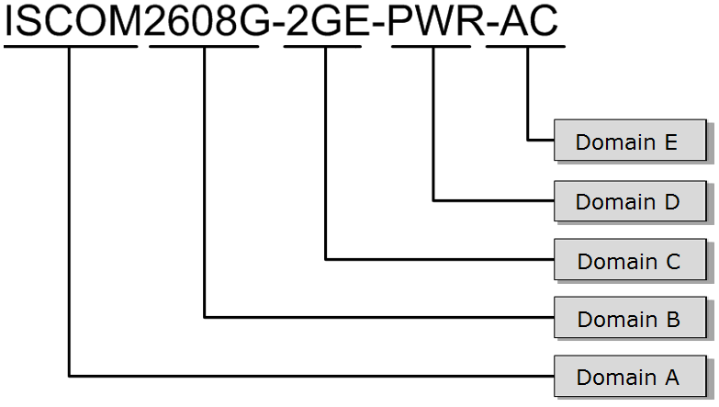

Table 1-2 describes naming convention for the ISCOM2608G series switch.

Naming convention

| Domain | Indication | Value | Description |
| --- | --- | --- | --- |
| A | Product ID | ISCOM | Raisecom ISCOM series device |
| B | Subtype and number of interfaces | 26 | One of the 2600 series |
| 8 | 8: provide 8 downlink interfaces. |
| C | Number and parameters of uplink interfaces | 2GE | Provide 2 uplink interfaces. |
| D | PoE | PWR | Support PoE. |
| – | Do not support PoE. |
| F | Power type | AC | Support AC power supply. |
| DC | Support DC power supply. |

### Ordering information about device

Table 1-3 lists ordering information about the ISCOM2608G series switch.

Ordering information about device

| Model | Description |
| --- | --- |
| ISCOM2608G-2GE-AC | * Support eight 10/100/1000 Mbit/s RJ45 downlink interfaces. * Support two SFP 100/1000Base-X interfaces. * Support one Console interface. * Support 220 VAC power supply. |
| ISCOM2608G-2GE-DC | * Support eight 10/100/1000 Mbit/s RJ45 downlink interfaces. * Support two SFP 100/1000Base-X interfaces. * Support one Console interface. * Support -48 VDC power supply. |
| ISCOM2608G-2GE-PWR-AC | * Support eight 10/100/1000 Mbit/s RJ45 downlink interfaces. * Support two SFP 100/1000Base-X interfaces. * Support one Console interface. * Support 220 VAC power supply. |
| ISCOM2608G-2GE-PWR-DC | * Support eight 10/100/1000 Mbit/s RJ45 downlink interfaces. * Support two SFP 100/1000Base-X interfaces. * Support one Console interfaces. * Support -48 VDC power supply. |

### Ordering information about auxiliary parts

The following auxiliary parts are not delivered by default. You can purchase them as required.

* + - 1. Installing accessories

Table 1-4 lists ordering information about the non-PoE model accessories.

Ordering information about non-PoE model accessories

| ERP code | Name | Quantity |
| --- | --- | --- |
| 20.08.03.0047.01 | ISCOM5104 (B) corner (customized for the 19'' rack) | 2 |
| 20.04.00.0004.02 | M3*6-flat head screw-chrome | 4 |
| 20.04.00.0043.02 | M6*16-pan head screw-chrome | 4 |
| 20.04.10.0006.02 | M6-cage nut-nickel | 4 |

Table 1-5 lists ordering information about the PoE model accessories.

Ordering information about PoE model accessories

| ERP code | Name | Quantity |
| --- | --- | --- |
| 20.08.03.0042.01 | RC953-4FE4E1T1 series corner (customized for the 19'' rack) | 2 |
| 20.04.00.0007.02 | M3*8-flat head screw-chrome | 4 |
| 20.04.00.0043.02 | M6*16-pan head screw-chrome | 4 |
| 20.04.10.0006.02 | M6-cage nut-nickel | 4 |

Table 1-6 lists ordering information about non-PoE model wall-mount accessories.

Ordering information about non-PoE model wall-mount accessories

| ERP code | Component name | Quantity |
| --- | --- | --- |
| 20.08.03.0048.01 | ISCOM5104(B) wall-mount plate | 2 |
| 20.04.00.0004.02 | M3*6-flat head screw-chrome | 4 |

Table 1-7 lists ordering information about PoE model wall-mount accessories.

Ordering information about PoE model wall-mount accessories

| ERP code | Component name | Quantity |
| --- | --- | --- |
| 20.08.03.0222.01 | Wall-mount plate | 2 |
| 20.04.00.0004.02 | M3*6-flat head screw-chrome | 6 |

* + - 1. 100 Mbit/s SFP optical module

Table 1-8 lists ordering information about the 100 Mbit/s SFP optical module.

Ordering information about 100 Mbit/s SFP optical module

| Model | Description |
| --- | --- |
| USFP-03/M-D-R/SW | * Transmission rate: 155 Mbit/s * Target transmission distance: 2 km * Tx wavelength: 1310 nm * Dual-fiber MM SFP optical module * DDM * RoHS-compliant |
| USFP-03/S1-D-R/SW | * Transmission rate: 155 Mbit/s * Target transmission distance: 15 km * Tx wavelength: 1310 nm * Dual-fiber SM SFP optical module * DDM * RoHS-compliant |
| USFP-03/S2-D-R/SW | * Transmission rate: 155 Mbit/s * Target transmission distance: 40 km * Tx wavelength: 1310 nm * Dual-fiber SM SFP optical module * DDM * RoHS-compliant |
| USFP-03/S3-D-R/SW | * Transmission rate: 155 Mbit/s * Target transmission distance: 80 km * Tx wavelength: 1550 nm * Dual-fiber SM SFP optical module * DDM * RoHS-compliant |
| USFP-03/SS13-D-R/SW | * Transmission rate: 155 Mbit/s * Target transmission distance: 15 km * Tx wavelength: 1310 nm * Single-fiber SM SFP optical module * DDM * RoHS-compliant |
| USFP-FE/AN03/SS15-D-R/SW | * Transmission rate: 155 Mbit/s * Target transmission distance: 15 km * Tx wavelength: 1550 nm * Single-fiber SM SFP optical module * DDM * RoHS-compliant |
| USFP-03/SS23-D-R/SW | * Transmission rate: 155 Mbit/s * Target transmission distance: 40 km * Tx wavelength: 1310 nm * Single-fiber SM SFP optical module * DDM * RoHS-compliant |
| USFP-03/SS25-D-R/SW | * Transmission rate: 155 Mbit/s * Target transmission distance: 40 km * Tx wavelength: 1550 nm * Single-fiber SM SFP optical module * DDM * RoHS-compliant |
| USFP-03/SS34-D-R/SW | * Transmission rate: 155 Mbit/s * Target transmission distance: 80 km * Tx wavelength: 1490 nm * Single-fiber SM SFP optical module * DDM * RoHS-compliant |
| USFP-03/SS35-D-R/SW | * Transmission rate: 155 Mbit/s * Target transmission distance: 80 km * Tx wavelength: 1550 nm * Single-fiber SM SFP optical module * DDM * RoHS-compliant |

* + - 1. 100 Mbit/s SFP electrical module

Table 1-9 lists ordering information about the 100 Mbit/s SFP electrical module.

Ordering information about 100 Mbit/s SFP electrical module

| Model | Description |
| --- | --- |
| USFP-FE/AN-R/SW | * 10/100BASE-T auto-negotiation * Target transmission distance: 100 m * Enabled with auto-negotiation * SerDes interface |

* + - 1. 1000 Mbit/s SFP optical module

Table 1-10 lists ordering information about the 1000 Mbit/s SFP optical module.

Ordering information about 1000 Mbit/s SFP optical module

| Model | Description |
| --- | --- |
| USFP-Gb/M-D-R/SW | * Transmission rate: 1.25 Gbit/s * Target transmission distance: 550 m * Tx wavelength: 850 nm * Dual-fiber MM SFP optical module * DDM * RoHS-compliant |
| USFP-Gb/S1-D-R/SW | * Transmission rate: 1.25 Gbit/s * Target transmission distance: 15 km * Tx wavelength: 1310 nm * Dual-fiber SM SFP optical module * DDM * RoHS-compliant |
| USFP-Gb/S2-D-R/SW | * Transmission rate: 1.25 Gbit/s * Target transmission distance: 40 km * Tx wavelength: 1550 nm * Dual-fiber SM SFP optical module * DDM * RoHS-compliant |
| USFP-Gb/S3-D-R/SW | * Transmission rate: 1.25 Gbit/s * Target transmission distance: 80 km * Tx wavelength: 1550 nm * Dual-fiber SM SFP optical module * DDM * RoHS-compliant |
| USFP-Gb/EX-D-R/SW | * Transmission rate: 1.25 Gbit/s * Target transmission distance: 80 km * Tx wavelength: 1550 nm * Dual-fiber SM SFP optical module * DDM * RoHS-compliant |
| USFP-Gb/SS13-D-R/SW | * Transmission rate: 1.25 Gbit/s * Target transmission distance: 15 km * Tx wavelength: 1310 nm * Single-fiber SM SFP optical module * DDM * RoHS-compliant |
| USFP-Gb/SS15-D-R/SW | * Transmission rate: 1.25 Gbit/s * Target transmission distance: 15 km * Tx wavelength: 1550 nm * Single-fiber SM SFP optical module * DDM * RoHS-compliant |
| USFP-Gb/SS24-D-R/SW | * Transmission rate: 1.25 Gbit/s * Target transmission distance: 40 km * Tx wavelength: 1490 nm * Single-fiber SM SFP optical module * DDM * RoHS-compliant |
| USFP-Gb/SS25-D-R/SW | * Transmission rate: 1.25 Gbit/s * Target transmission distance: 40 km * Tx wavelength: 1550 nm * Single-fiber SM SFP optical module * DDM * RoHS-compliant |
| USFP-Gb/SS34-D-R/SW | * Transmission rate: 1.25 Gbit/s * Target transmission distance: 80 km * Tx wavelength: 1490 nm * Single-fiber SM SFP optical module * DDM * RoHS-compliant |
| USFP-Gb/SS35-D-R/SW | * Transmission rate: 1.25 Gbit/s * Target transmission distance: 80 km * Tx wavelength: 1550 nm * Single-fiber SM SFP optical module * DDM * RoHS-compliant |
| USFP-Gb/LH1-D-R/SW | * Transmission rate: 1.25 Gbit/s * Target transmission distance: 40 km * Tx wavelength: 1310 nm * Dual-fiber SM SFP optical module * DDM * RoHS-compliant |
| CSFP-Gb/S/47-D-R/SW | * Transmission rate: 1.25 Gbit/s * Target transmission distance: 40 km * Tx wavelength: 1471 nm * DDM * RoHS-compliant |
| CSFP-Gb/S/49-D-R/SW | * Transmission rate: 1.25 Gbit/s * Target transmission distance: 40 km * Tx wavelength: 1491 nm * DDM * RoHS-compliant |
| CSFP-Gb/S/51-D-R/SW | * Transmission rate: 1.25 Gbit/s * Target transmission distance: 40 km * Tx wavelength: 1511 nm * DDM * RoHS-compliant |
| CSFP-Gb/S/53-D-R/SW | * Transmission rate: 1.25 Gbit/s * Target transmission distance: 40 km * Tx wavelength: 1531 nm * DDM * RoHS-compliant |
| CSFP-Gb/S/55-D-R/SW | * Transmission rate: 1.25 Gbit/s * Target transmission distance: 40 km * Tx wavelength: 1551 nm * DDM * RoHS-compliant |
| CSFP-Gb/S/57-D-R/SW | * Transmission rate: 1.25 Gbit/s * Target transmission distance: 40 km * Tx wavelength: 1571 nm * DDM * RoHS-compliant |
| CSFP-Gb/S/59-D-R/SW | * Transmission rate: 1.25 Gbit/s * Target transmission distance: 40 km * Tx wavelength: 1591 nm * DDM * RoHS-compliant |
| CSFP-Gb/S/61-D-R/SW | * Transmission rate: 1.25 Gbit/s * Target transmission distance: 40 km * Tx wavelength: 1611 nm * DDM * RoHS-compliant |
| CSFP-Gb/L/47-D-R/SW | * Transmission rate: 1.25 Gbit/s * Target transmission distance: 80 km * Tx wavelength: 1471 nm * DDM * RoHS-compliant |
| CSFP-Gb/L/49-D-R/SW | * Transmission rate: 1.25 Gbit/s * Target transmission distance: 80 km * Tx wavelength: 1491 nm * DDM * RoHS-compliant |
| CSFP-Gb/L/51-D-R/SW | * Transmission rate: 1.25 Gbit/s * Target transmission distance: 80 km * Tx wavelength: 1511 nm * DDM * RoHS-compliant |
| CSFP-Gb/L/53-D-R/SW | * Transmission rate: 1.25 Gbit/s * Target transmission distance: 80 km * Tx wavelength: 1531 nm * DDM * RoHS-compliant |
| CSFP-Gb/L/55-D-R/SW | * Transmission rate: 1.25 Gbit/s * Target transmission distance: 80 km * Tx wavelength: 1551 nm * DDM * RoHS-compliant |
| CSFP-Gb/L/57-D-R/SW | * Transmission rate: 1.25 Gbit/s * Target transmission distance: 80 km * Tx wavelength: 1571 nm * DDM * RoHS-compliant |
| CSFP-Gb/L/59-D-R/SW | * Transmission rate: 1.25 Gbit/s * Target transmission distance: 80 km * Tx wavelength: 1591 nm * DDM * RoHS-compliant |
| CSFP-Gb/L/61-D-R/SW | * Transmission rate: 1.25 Gbit/s * Target transmission distance: 80 km * Tx wavelength: 1611 nm * DDM * RoHS-compliant |

# Networking applications

This chapter describes typical networking applications of the ISCOM2608G series switch, including the following sections:

* Enterprise park network access
* Residential area broadband access

## Enterprise park network access

As shown in Figure 2-1, in the enterprise park network access networking, the ISCOM2608G series switch, as an access device, is connected downstream to data devices from enterprises, campuses, and residential areas and upstream to a Layer 3 aggregation device, accessing and transmitting broadband, voice, wireless, and video services. This networking can meet the customer's high-bandwidth and multi-service access requirements.

Enterprise park network access networking

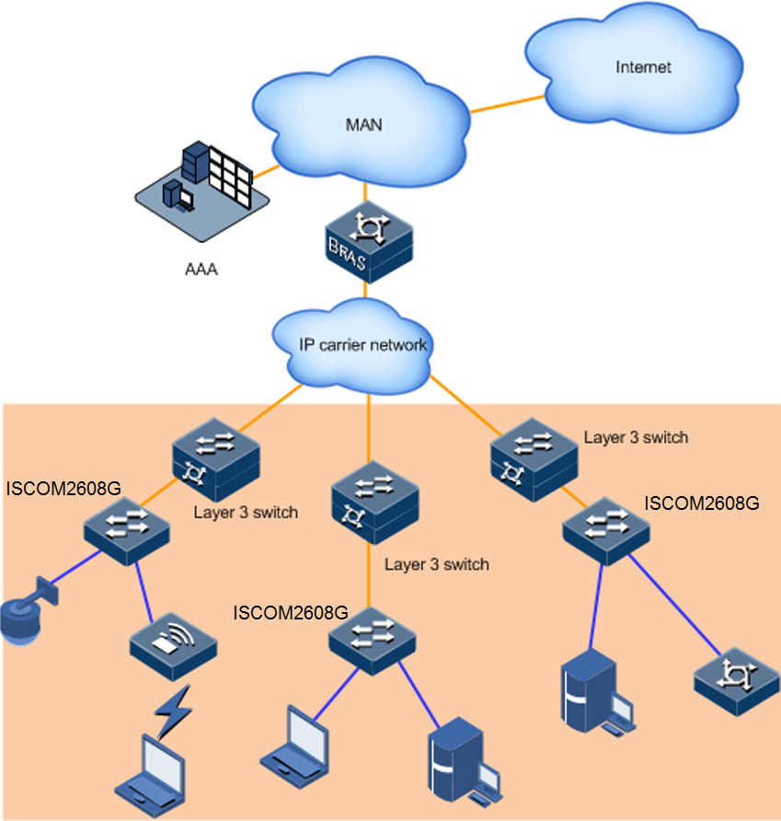

## Residential area broadband access

As an access switch, the ISCOM2608G series switch can work as a core switch for a small network. As shown in Figure 2-2, the ISCOM2608G series switch is connected to the L3 aggregation switch through the 10GE interface and downstream to the 1000 Mbit/s switch through the GE interface.

Residential area broadband access networking

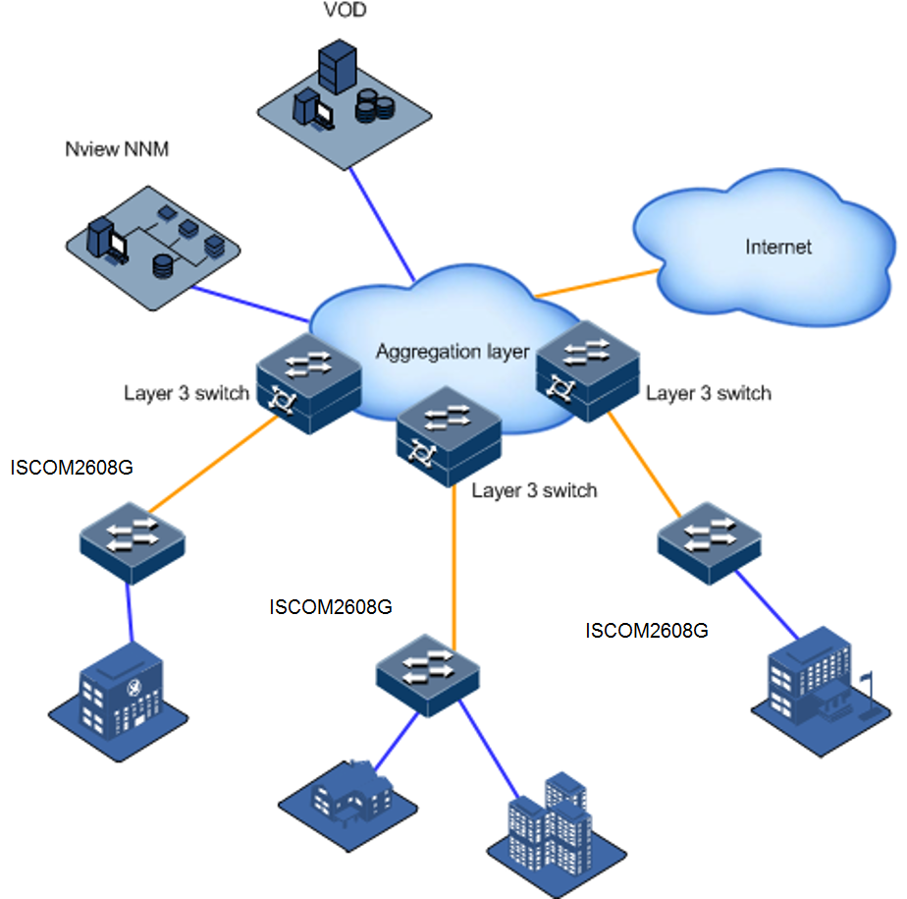

# System structure

This chapter describes system structure of the ISCOM2608G series switch, including the following sections:

* Panels
* Interfaces
* Power interfaces
* LEDs

## Panels

### Front panels

* + - 1. ISCOM2608G-2GE-AC

Figure 3-1 shows the front panel of the ISCOM2608G-2GE-AC.

Front panel of ISCOM2608G-2GE-AC

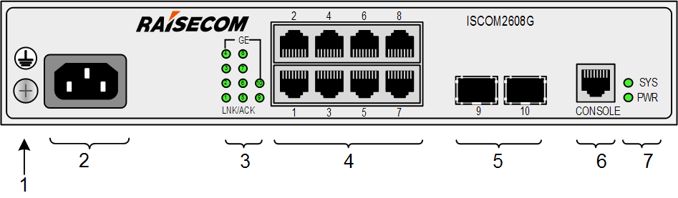

| 1 | Ground terminal | 2 | Power interface |
| --- | --- | --- | --- |
| 3 | Service interfaces (1–10) LEDs | 4 | Service downlink interfaces (1–8) |
| 5 | Service uplink SFP optical interfaces (9–10) | 6 | Console interface |
| 7 | PWR and SYS LEDs |  |  |

* + - 1. ISCOM2608G-2GE-DC

Figure 3-2 shows the front panel of the ISCOM2608G-2GE-DC.

Front panel of ISCOM2608G-2GE-DC

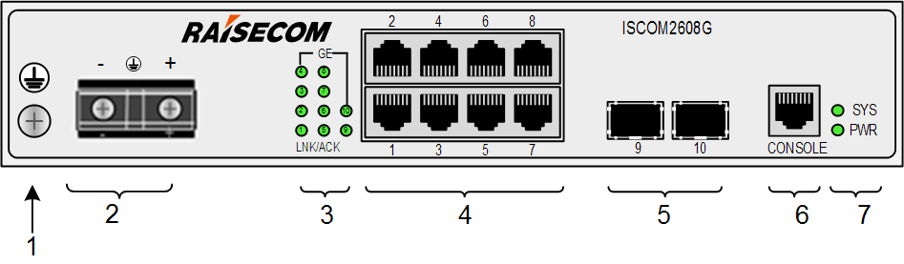

| 1 | Ground terminal | 2 | Power connector |
| --- | --- | --- | --- |
| 3 | Service interfaces (1–10) LEDs | 4 | Service downlink interfaces (1–8) |
| 5 | Service uplink SFP optical interfaces (9–10) | 6 | Console interface |
| 7 | SNMP interface and PWR and SYS LEDs |  |  |

* + - 1. ISCOM2608G-2GE-PWR-AC

Figure 3-3 shows the front panel of the ISCOM2608G-2GE-PWR-AC.

Front panel of ISCOM2608G-2GE-PWR-AC

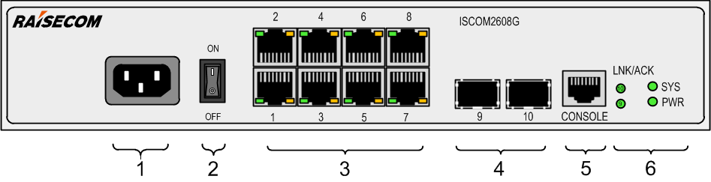

| 1 | Power interface | 2 | Power switch |
| --- | --- | --- | --- |
| 3 | Service interfaces (1–8) and LEDs | 4 | Service uplink SFP optical interfaces (9–10) |
| 5 | Console interface | 6 | Service uplink interfaces (9–10), PWR, and SYS LEDs |

* + - 1. ISCOM2608G-2GE-PWR-DC

Figure 3-4 shows the front panel of the ISCOM2608G-2GE-PWR-DC.

Front panel of ISCOM2608G-2GE-PWR-DC

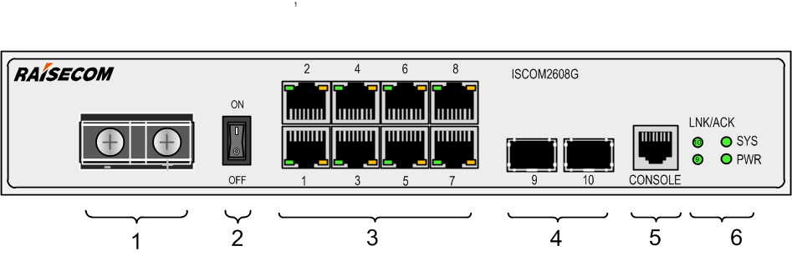

| 1 | Power interface | 2 | Power switch |
| --- | --- | --- | --- |
| 3 | Service interfaces (1–8) and LEDs | 4 | Service uplink SFP optical interfaces (9–10) |
| 5 | Console interface | 6 | Service uplink interfaces (9–10), PWR, and SYS LEDs |

### Rear panels

* + - 1. ISCOM2608G-2GE-AC/DC

Figure 3-5 shows the rear panel of the ISCOM2608G-2GE-AC/DC.

Rear panel of ISCOM2608G-2GE-AC/DC

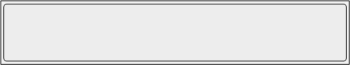

* + - 1. ISCOM2608G-2GE-PWR-AC/DC

Figure 3-6 shows the rear panel of the ISCOM2608G-2GE-PWR-AC/DC.

Rear panel of ISCOM2608G-2GE-PWR-AC/DC

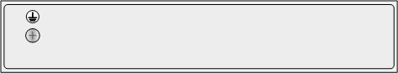

## Interfaces

The ISCOM2608G series switch provides external interfaces, such as service interfaces, management interfaces, and power interfaces.

### Service interfaces

Table 3-1 lists service interfaces on the ISCOM2608G series switch.

Service interfaces

| Interface | | Quantity | Description |
| --- | --- | --- | --- |
| Uplink interfaces | ISCOM2608G-2GE | 2 | The SFP interface supports the following SFP optical modules:   * 1000BASE-X * 100BASE-FX |
| ISCOM2608G-2GE-PWR | 2 | The SFP interface supports the following SFP optical modules:   * 1000BASE-X * 100BASE-FX |
| Downlink interfaces | ISCOM2608G-2GE | 8 | 10/100/1000BASE-T adaptive electrical interface |
| ISCOM2608G-2GE-PWR | 8 | 10/100/1000BASE-T adaptive electrical interface   * All interfaces can supply power through PoE+. * Support supplying power for the remote PD through PoE. * Support up to 30 W output power per interface. * Support a total power supply of up to 124 W through 8 interfaces (each interface supplies 15.4 W) or 4 interfaces (each interface supplies 30 W). |

* + - 1. 1000 Mbit/s SFP optical interface

Table 3-2 lists parameters of the 1000 Mbit/s SFP optical interface.

Parameters of 1000 Mbit/s SFP optical interface

| Parameter | Description |
| --- | --- |
| Connector type | LC/PC |
| Optical interface properties | Depend on the selected SFP optical module. |
| Coding type | 8B/10B |
| Working mode | Full duplex |
| Standard | IEEE 802.3-compliant |

* + - 1. 100 Mbit/s SFP optical interface

Table 3-3 lists parameters of the 100 Mbit/s SFP optical interface.

Parameters of 100 Mbit/s SFP optical interface

| Parameter | Description |
| --- | --- |
| Connector type | LC/PC |
| Optical interface properties | Depend on the selected SFP optical module. |
| Coding type | 4B/5B |
| Working mode | Full duplex |
| Standard | IEEE 802.3-compliant |

### Management interfaces

Table 3-4 lists types and usage of management interfaces on the ISCOM2608G series switch.

Management interfaces

| Interface | Description |
| --- | --- |
| Console (RJ45) | Local management and control interface. You can log in to the ISCOM2608G series switch through Hyper Terminal to conduct local management and configurations. |

* + - 1. RJ45 Console interface

Table 3-5 lists parameters of the RJ45 Console interface.

Parameters of RJ45 Console interface

| Parameter | Description |
| --- | --- |
| Connector type | RJ45 |
| Working mode | Duplex UART |
| Electrical feature | RS-232 |
| Baud rate | 9600Baud |

## Power interfaces

### DC power

* + - 1. Introduction

The DC power supply provides -48 VDC power.

* + - 1. Interface

There is a DC power input interface for inputting DC power on the panel of the ISCO2608G series switch, as shown in Figure 3-7.

DC power interface

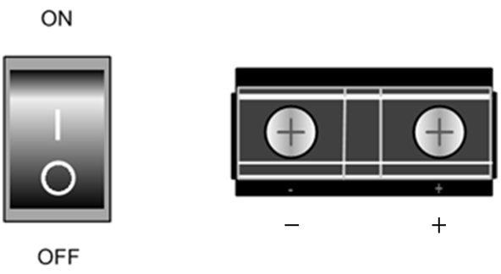

Table 3-6 describes the DC power interface.

DC power interface

| Power interface | Type | Print | Usage |
| --- | --- | --- | --- |
| DC power interface | Fence terminal | – | -48V power input terminal |
| + | GND power input terminal |

* + - 1. Parameters

Table 3-7 lists parameters of the DC power interface.

Parameters of DC power interface

| Parameter | Description |
| --- | --- |
| Rated input voltage | -48 VDC |
| Voltage range | -36 to -72 VDC |

### AC power interface

* + - 1. Introduction

The AC power supply supports the following features:

* Supply 220 VAC power supply.
* Support a lightning protection level of 6 kV in both common mode and differential mode.
  + - 1. Interfaces

There is an AC power input interface for inputting AC power on the panel of the ISCO2608G series switch, as shown in Figure 3-8.

AC power interface

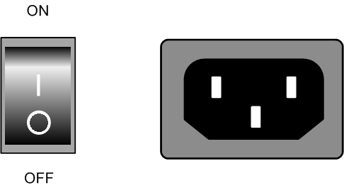

* + - 1. Parameters

Table 3-8 lists parameters of the AC power interface.

Parameters of AC power interface

| Parameter | Description |
| --- | --- |
| Rated input voltage | 220 VAC |
| Voltage range | 100–240 VAC |

## LEDs

### ISCOM2608G-2GE

Table 3-9 lists LEDs on the ISCOM2608G-2GE.

LEDs on ISCOM2608G-2GE

| LED | Status | Description |
| --- | --- | --- |
| LNK/ACT  1–10 | Green | Ethernet interface working status LED   * Green: the interface is properly connected. * Blinking green: the interface is receiving or sending data. * Off: the interface is disconnected or improperly connected. |
| PWR | Green | Power working status LED   * Green: the power supply is normal. * Off: the power supply is off, the power module fails, or the power supply is configured as a single power supply and not installed. |
| SYS | Green | System working LED   * Green: the system is working improperly. * Blinking green (every 1s): the system has loaded the configuration file or the device is configured. * Off: the system is working improperly. |

### ISCOM2608G-2GE-PWR

Table 3-10 lists LEDs on the ISCOM2608G-2GE-PWR.

LEDs on ISCOM2608G-2GE-PWR

| LED | Status | Description |
| --- | --- | --- |
| LNK/ACT  1–10 | Green | Ethernet interface working status LED   * Green: the interface is properly connected. * Blinking green: the interface is receiving or sending data. * Off: the interface is disconnected or improperly connected. |
| –  Port 1–Port 8 PoE | Yellow | PoE working status LED   * Yellow: the interface is supplying power to the remote device. * Off: the interface is not supplying power to the remote device. |
| LNK/ACT  9–10 | Green | Service uplink interface working status LED   * Green: the interface is properly connected. * Blinking green: the interface is receiving or sending data. * Off: the interface is disconnected or improperly connected. |
| PWR | Green | Power working status LED   * Green: the power supply is normal. * Off: the power module is not powered on or the power module fails. |
| SYS | Green | System working LED   * Green: the system is working improperly. * Blinking green (every 1s): the system has loaded the configuration file or the device is configured. * Off: the system is working improperly. |

# Device installation

This chapter describes how to install the ISCOM2608G series switch, including the following sections:

* Installing hardware
* Installing software

## Installing hardware

The ISCOM2608G series switch adopts a 1U cartridge structure. It can be easily installed in the following scenarios of a telecom equipment room:

* Cabinet
* Workbench

### Preparing for installation

* + - 1. Environment conditions

Table 4-1 lists requirements on the operation environment of the ISCOM2608G series switch.

Requirements on operation environment

| Parameter | Description |
| --- | --- |
| Operating temperature (altitude 0–1800 m) | 0–50°C |
| Operating humidity | 10%–90% RH (non-condensing) |
| Storage temperature | -25 to 60°C |
| Air pressure | 86–106 kPa |

说明: Note.png

When the altitude is from 1800m to 5000m, every time the altitude is increased by 220 m, the maximum operating temperature of the equipment will be decreased by 1°C.

* + - 1. Power supply conditions

Table 4-2 lists power supply requirements on the operation of the ISCOM2608G series switch.

Power supply requirements on operation

| Parameter | Description |
| --- | --- |
| Power supply | * AC power: the rated voltage is 220 VAC, and the voltage range is 100–240 VAC. * DC power: the rated voltage is -48 VDC, and the voltage range is -36 to -72 VDC. |
| Maximum power consumption | * ISCOM2608G-2GE: 15 W * ISCOM2608G-2GE-PWR: up to 141 W, the PoE interfaces supply power up to 124 W. |

说明: Warning.png

The ISCOM2608G series switch is supplied by multiple power supplies. Do remember to disconnect all power inputs when powering off the device.

* + - 1. Grounding conditions

The ISCOM2608G series switch adopts common earthing mode, and the ground resistance should be no greater than 1 Ω. Well grounding is the first guarantee for lightning protection and anti-interference.

### Installing device

* + - 1. Rack installation

说明: Note.png

The installation mode of the ISCOM2608G series switch is identical. The following installation takes the ISCOM2608G-2GE for example. The ISCOM2608G series switch adopts the non-standard 1U chassis. If you wish to install them in a rack, buy the customized 19'' brackets additionally.

说明: Caution.png

The brackets, which are only for positioning, cannot bear the weight of the device. Therefore, you have to install the device to a guide rail or a tray. Prepare the guide rail or tray by yourself.

The ISCOM2608G-2GE supports being installed in the rack, with steps as below:

Ensure that the rack is stable.

Install two customized brackets on the two sides of the ISCOM2608G series switch respectively, and fix them with screws, as shown in Figure 4-1.

Installing brackets

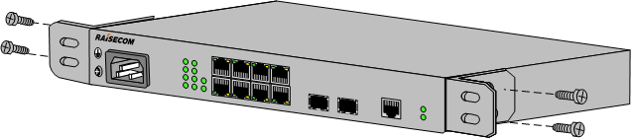

Install cage nuts in the rack, as shown in Figure 4-2.

Installing cage nuts

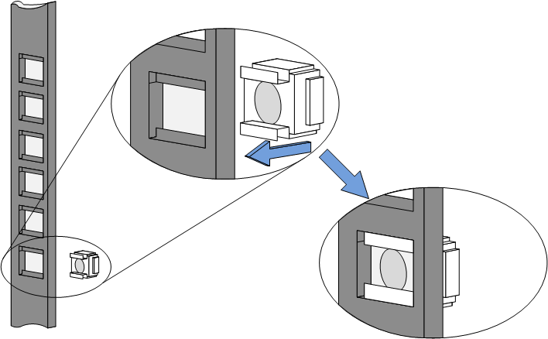

Install guide rails in the rack, as shown in Figure 4-3.

Installing guide rails

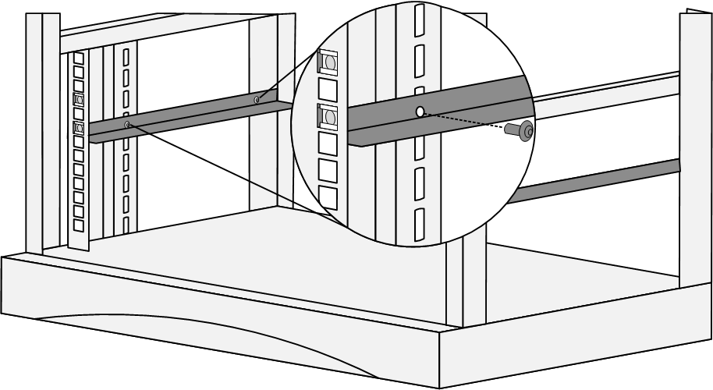

Use screws to fix two customized brackets to guide rail, and install the ISCOM2648G-4C horizontally in the rack, as shown in Figure 4-4.

Installing device horizontally in rack

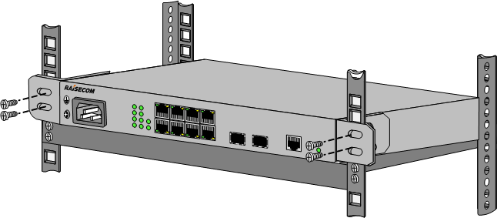

说明: Caution.png

Do not lay heavy objects or coverings on the ISCOM2608G series switch.

* + - 1. Wall-mount installation

说明: Note.png

At present, the ISCOM2608G series switch supports wall-mount installation. The wall-mount brackets and M3*6 screws used during installation are accessories. Purchase them additionally as required.

The ISCOM2608G-2GE supports wall-mount installation with the installation steps as below:

Choose a proper wall-mount height where you can easily observe the LEDs and connect the power supply.

Use the M3*6 screws to install the wall-mount brackets to the two sides of the device (Figure 4-5 shows how to install brackets to one side. Do the same on the other side.), as shown in Figure 4-5.

Installing wall-mount brackets

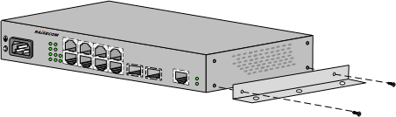

Drill four holes on the wall according to the distance of the two holes on the brackets and the device width. Keep the lines connected by the brackets horizontal and vertical and fix four screws to the wall, as shown in Figure 4-6.

Installing screws

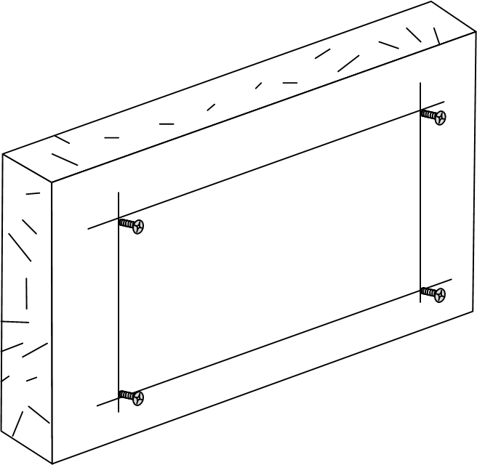

Align the holes on the wall-mount brackets with the screws, snap the device slightly, and then let go of your hands, as shown in Figure 4-7.

Wall-mount installation

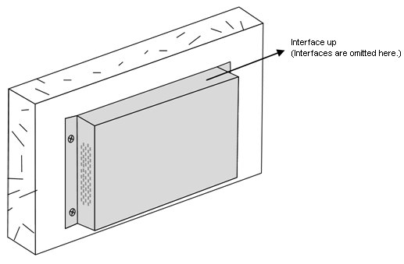

Swing the device using proper strength to see whether it is secured.

### Connecting cables

* + - 1. Connecting fiber

说明: Warning.png

There is invisible laser which harms eyes inside the ISCOM2608G series switch. Do not stare into the optical interface, fiber connector, or breakage of fiber directly.

Connect fiber as below:

Remove the dustproof cover from the SFP optical interface and SFP optical module, and insert the SFP optical module into the optical interface on the ISCOM2608G series switch, as shown in Figure 4-8.

Inserting SFP optical module

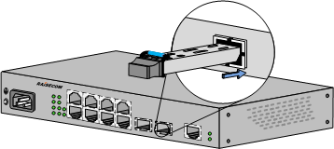

Remove the dustproof cover from the LC/PC fiber, align the fiber with the SFP optical interface, and insert the fiber slightly into the SFP optical interface, as shown in Figure 4-9.

Connecting fiber

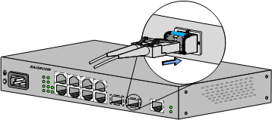

说明: Note.png

Figure 4-9 takes the 1000 Mbit/s SFP optical module for example. The connection of the 10 Gbit/s SFP+ optical module is identical.

When the optical interface is idle, cover it with a dustproof cap to prevent dust and dirt which may make the ISCOM2608G series switch work improperly.

* + - 1. Connecting Ethernet cable

Connect the Ethernet cable as below:

Choose a proper length for the Ethernet cable according to cabling path, and make an Ethernet cable accordingly.

Insert the RJ45 connector of the Ethernet cable into the Ethernet interface of the ISCOM2608G series switch, and insert the other RJ45 connector of the Ethernet cable into the Ethernet interface of the peer device, as shown in Figure 4-10.

Connecting Ethernet cable

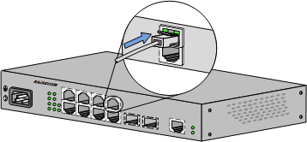

* + - 1. Connecting ground cable

说明: Warning.png

Connecting the ground cable properly is an important guarantee for lightning protection, shock proof, and anti-interference. When installing and using the device, ensure that the ground cable is properly connected; otherwise, personnel injury or equipment damage may occur.

Install the ground cable as below:

Unscrew ground terminal counterclockwise, and remove the screws and washers.

Sheathe the flat washer, ground OT terminal, and lock washer in sequence over the screw.

Reinstall the screw to the ground terminal, and tighten the screws clockwise, as shown in Figure 4-11.

Connecting ground cable

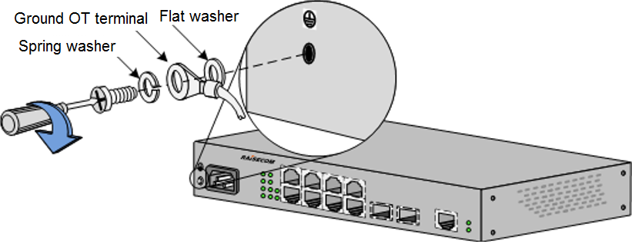

* + - 1. Connecting AC power cable

Connect the AC power cable as below:

Ensure that the ISCOM2608G series switch is well grounded.

Insert the C13 connector of the AC power cable into the AC power interface on the rear panel tightly. Insert the power plug of the AC power cable into the AC power socket of the power sourcing equipment, as shown in Figure 4-12.

Connecting AC power cable

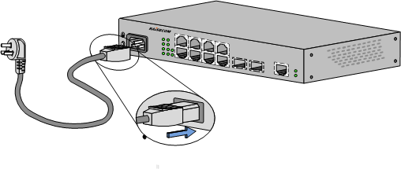

* + - 1. Connecting DC power

Connect the DC power cable as below:

Ensure that the ISCOM2608G series switch is well grounded.

Open the cover on the power interface. Loosen the screws and then connect the DC power cable.

Fasten the screws and then close the cover, as shown in Figure 4-13.

Connecting DC power cable

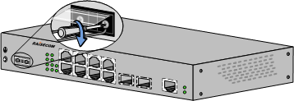

Connect the other end of the DC power cable to the power sourcing equipment in the equipment room.

* + - 1. Connecting RJ45 Console cable

Install the RJ45 Console cable as below:

Insert the RJ45 connector of the RJ45 Console cable into the Console interface on the ISCOM2608G series switch.

Insert the other end of the RJ45 Console cable into the RS-232 serial interface on a PC (or maintenance terminal).

## Installing software

The ISCOM2608G series switch is installed with all necessary software before delivery so that it can be powered on immediately for use after hardware installation is complete.

You can upgrade software of the ISCOM2608G series switch. For details, see *ISCOM2608G (B) Series Configuration Guide*.

For details about installation and operations about the NView NNM network management software, see the related NView NNM manual.

# Technical specifications

This chapter describes overall parameters, system parameters, card parameters, and technical specifications, including the following sections:

* Overall parameters
* Laser safety class
* Reliability specifications
* EMC specifications
* Safety standards
* Environmental requirements
* Standards and protocols

## Overall parameters

Table 5-1 lists overall parameters of the ISCOM2608G.

Overall parameters of the ISCOM2608G series switch

| Parameter | | Description |
| --- | --- | --- |
| Dimensions | | * ISCOM2608G-2GE: 260 (Width) × 130 (Depth) × 44 (Height) * ISCOM2608G-2GE-PWR: 300 (Width) × 220 (Depth) × 44 (Height) |
| Overall power consumption (W) | | * ISCOM2608G-2GE: 15 * ISCOM2608G-2GE-PWR: up to 141, the PoE interface supplies power up to 124. |
| Weight (kg) | | * ISCOM2608G-2GE: 1.0 * ISCOM2608G-2GE-PWR-AC: 2.3 * ISCOM2608G-2GE-PWR-DC: 2.4 |
| Operating temperature (altitude 0–1800 m) | | 0–50°C |
| Operating humidity | | 10%–90% RH (non-condensing) |
| DC power | Rated voltage | -48 VDC |
| Voltage range | -36 to -72 VDC |
| AC power | Rated voltage | 220 VAC |
| Voltage range | 100–240 VAC (50/60 Hz) |
| Maximum current | | * ISCOM2608G-2GE-AC: 0.12 A * ISCOM2608G-2GE-DC: 0.17 A * ISCOM2608G-2GE-PWR-AC: 1.77 A   ISCOM2608G-2GE-PWR-DC: 4.01 A |
| Lightning protection level | AC power | * ISCOM2624G-4C: 6 kV in differential mode and 6 kV in common mode * ISCOM2624G-4GE: 6 kV in differential mode and 6 kV in common mode * ISCOM2648G-4C: 1 kV in differential mode and 2 kV in common mode * I ISCOM2608G-2GE: 6 kV in differential mode, 6 kV in common mode * ISCOM2608G-2GE-PWR: 6 kV in differential mode, 6 kV in common mode * ISCOM2624G-4GE: 6 kV in differential mode, 6 kV in common mode * ISCOM2624G-4GE-PWR: 6 kV in differential mode, 6 kV in common mode * ISCOM2624G-4GE-RPS: 6 kV in differential mode, 6 kV in common mode * ISCOM2624G-4C: 6 kV in differential mode, 6 kV in common mode * ISCOM2624G-4C-PWR: 6 kV in differential mode, 6 kV in common mode * ISCOM2648G-4GE: 6 kV in differential mode, 6 kV in common mode * ISCOM2648G-4GE-RPS: 6 kV in differential mode, 6 kV in common mode * ISCOM2648G-4C: 1 kV in differential mode, 2 kV in common mode |
| DC power | * 1 kV in differential mode * 2 kV in common mode |
| Ethernet electrical interface | 6 kV in indoor common mode |

## Laser safety class

According to the Tx power of Laser, the ISCOM2608G series switch laser belongs to Class 1 in safety class.

In Class 1, the maximum Tx power on the optical interface is smaller than 10 dBm (10 mW).

说明: Warning.png

The laser inside fiber may hurt your eyes. Do not stare into the optical interface directly during installation and maintenance.

## Reliability specifications

Table 5-2 lists reliability specifications of the ISCOM2608G series switch.

Reliability specifications

| Parameter | Description |
| --- | --- |
| System availability | 99.999%. The annual failure time for the ISCOM2608G series switch should be no longer than 5 minutes. |
| Annually system mean repair rate | < 1.5% |
| MTTR | < 2 hours |

## EMC specifications

The ISCOM2608G series switch, designed according to ETS 300 386 series and ETS 300 127 series of European Telecommunication Standards Institute (ETSI), has passed Electromagnetic Compatibility (EMC) tests.

## Safety standards

The ISCOM2608G series switch complies with the following safety standards:

* EN 60950
* UL 60950
* CSA C22.2 No. 60950-1-03
* CSA C22.2 No. 60950-1-07

说明: Warning.png

The ISCOM2608G series switch is rated as a Class A device. In the living environment, they may cause radio interference. In this case, you may need to take practical measures against the interference.

## Environmental requirements

The ISCOM2608G series switch complies with the following environmental requirements:

* GF 014-1995: telecommunication equipment room conditions
* NEBS GR-63-CORE: Network Equipment-Building System (NEBS) Requirements: Physical Protection
* European Telecommunication Standards Institute (ETSI) EN 300 019

### Storage environment

* + - 1. Atmosphere environment

Table 5-3 lists atmosphere requirements for the ISCOM2608G series switch during storage.

Atmosphere requirements during storage

| Parameter | Description |
| --- | --- |
| Air pressure (kPa) | 86–106 |
| Temperature (°C) | -25 to +60 |
| Relative humidity | 10%–90% |
| Solar radiation (W/s²) | ≤ 1120 |
| Heat radiation (W/s²) | ≤ 600 |
| Wind speed (m/s) | ≤ 20 |

* + - 1. Waterproof environment

We recommend keeping the ISCOM2608G series switch indoor on the following conditions:

* No ponding on the ground
* No water dropping above the package box
* Away from any water leakage area, such as the automatic fire-fighting equipment or heater

If the ISCOM2608G series switch is stored outdoor, ensure the following four prerequisites:

* The package box is intact.
* Rainproof measures are taken so that rain will not leak into the package box.
* No ponding is around the package box.
* The package box is not directly exposed to the sun.
  + - 1. Biotic environment

Keep the ISCOM2608G series switch away from:

* Fungus and mould
* Rodent animals, such as rats

### Transport environment

* + - 1. Atmosphere environment

Table 5-4 lists atmosphere requirements for the ISCOM2608G series switch during transport.

Atmosphere requirements during transport

| Parameter | Description |
| --- | --- |
| Air pressure (kPa) | 86–106 |
| Temperature (°C) | -25 to +60 |
| Temperature change rate (°C/min) | ≤ 1 |
| Operating humidity | 10%–90% |
| Solar radiation (W/s²) | ≤ 1120 |
| Heat radiation (W/s²) | ≤ 600 |
| Wind speed (m/s) | ≤ 20 |

* + - 1. Waterproof environment

When transporting the ISCOM2608G series switch, ensure the following prerequisites:

* The package box is intact.
* Rainproof measures are taken so that rain will not leak into the package box.
* No ponding is inside the transport vehicle.

### Operation environment

* + - 1. Atmosphere environment

Table 5-5 lists atmosphere requirements for the ISCOM2608G series switch during operation.

说明: Note.png

The temperate and humidity referred to are measured 1.5 m above or 0.4 m in front of the ISCOM2608G series switch.

Atmosphere requirements during operation

| Parameter | Description |
| --- | --- |
| Air pressure (kPa) | 86–106 |
| Temperature (°C) | 0–50 |
| Relative humidity | 10%–90% (non-condensing) |
| Temperature change rate (°C/min) | ≤ 0.5 |
| Solar radiation (W/s²) | ≤ 700 |
| Heat radiation (W/s²) | ≤ 600 |
| Wind speed (m/s) | ≤ 5 |

* + - 1. Biotic environment

Keep the ISCOM2608G series switch away from:

* Fungus and mould
* Rodent animals, such as rats

## Standards and protocols

The ISCOM2608G series switch complies with the following standards and protocols:

* MEF Technical Specification MEF 6.1 Ethernet Services Definitions - Phase 2
* MEF Implementation Agreement, MEF 8 Implementation Agreement for the Emulation of PDH Circuits over Metro Ethernet networks
* MEF Technical Specification, MEF 10.1 Ethernet Services Attributes - Phase 2
* MEF Technical Specification, MEF 11 User Network Interface (UNI) Requirements and Framework
* MEF Technical Specification, MEF 13 User Network Interface (UNI) Type 1 Implementation Agreement
* MEF Technical Specification, MEF 17 Service OAM Requirements & Framework
* MEF Technical Specification, MEF 20 User Network Interface (UNI) Type 2 Implementation Agreement
* IEEE 802.1D-2004 Part 3: Media Access Control (MAC) Bridges
* IEEE 802.1Q-2005 - Standard for Local and Metropolitan Area Networks - Virtual Bridged Local Area Networks
* IEEE 802.1s-2002 - Amendment to 802.1Q Virtual Bridged Local Area Networks: Multiple Spanning Trees
* IEEE 802.3-2005 Part 3: Carrier sense multiple access with collision detection (CSMA/CD) access method and physical layer specifications
* IEEE 802.1ag: Virtual Bridged Local Area Networks Amendment 5: Connectivity Fault Management
* IEEE 1588-2008 Standard for a Precision Clock Synchronization Protocol for Network Measurement and Control Systems
* ITU-T Y.1541 Network Performance Objectives For IP-Based Services
* ITU-T Y.1731 OAM Functions and Mechanisms for Ethernet based networks
* ITU-T G.8031 Ethernet linear protection switching
* ITU-T G.8032 Ethernet ring protection switching
* ITU-T G.8261 Timing and Synchronization Aspects in Packet Networks
* ITU-T G.8262 Timing Characteristics of Synchronous Ethernet Equipment Slave Clock (EEC)
* ITU-T G.823 The control of jitter and wander within digital networks which are based on the 2048 kbit/s hierarchy
* ITU-T G.824 The control of jitter and wander within digital networks which are based on the 1544 kbit/s hierarchy
* ITU-T G.825 The control of jitter and wander within digital networks which are based on synchronous digital hierarchy (SDH)
* RFC1349 Type of Service in the Internet Protocol Suite
* RFC2474 Definition of the Differentiated Services Field (DS Field) in the IPv4 and IPv6 Headers
* RFC2475 An Architecture for Differentiated Services
* RFC2597 Assured Forwarding PHB Group
* RFC2598 An Expedited Forwarding PHB
* RFC2698 A Two Rate Three Color Marker
* RFC3086 Definition of Differentiated Services Per Domain Behaviors and Rules for their Specification
* RFC3140 Per Hop Behavior Identification Codes
* RFC3246 An Expedited Forwarding PHB (Per-Hop Behavior)
* RFC3247 Supplemental Information for the New Definition of the EF PHB (Expedited Forwarding Per-Hop Behavior)
* RFC3248 A Delay Bound alternative revision of RFC 2598
* RFC3260 New Terminology and Clarifications for DiffServ
* RFC3289 Management Information Base for the Differentiated Services Architecture
* RFC3290 An Informal Management Model for DiffServ Routers
* RFC3317 Differentiated Services Quality of Service Policy Information Base

# Appendix

The appendix lists cables, SFP modules, terms, acronyms, and abbreviations, including the following sections:

* Cables
* Terms
* Acronyms and abbreviations

## Cables

The following cables are used when connecting the ISCOM2608G series switch:

* Cables
* Ethernet cable
* Ground cable
* DC power cable
* AC power cable
* RJ45 Console cable

### Fiber

* + - 1. Introduction

The ISCOM2608G series switch supports Single-mode Fiber (SMF) and Multi-mode Fiber (MMF).

Table 6-1 lists fiber connectors available for the ISCOM2608G series switch.

Fiber connectors

| Local connector | Remote connector | Fiber |
| --- | --- | --- |
| LC/PC | LC/PC | 2 mm SMF |
| 2 mm MMF |
| FC/PC | 2 mm SMF |
| 2 mm MMF |
| SC/PC | 2 mm SMF |
| 2 mm MMF |

Note.png

Choose the fiber connector properly as required on site. Otherwise, extra fiber loss will occur, service transmission will be deteriorated, and even the fiber connector and interface may be damaged.

* + - 1. Appearance

Figure 6-1 shows the LC/PC fiber connector.

LC/PC fiber connector

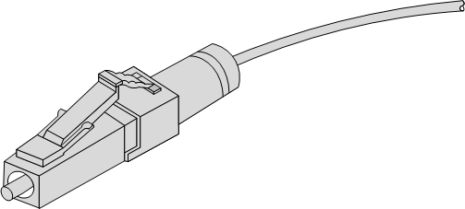

When connecting or removing the LC/PC optical connector, align the connector with the optical interface, and do not rotate the fiber. Operate the fiber as below:

* Align the head of the fiber jumper with the optical interface and insert the optical fiber into the interface gently.
* To remove the fiber, press the latch on the connector, press the fiber head inwards slightly, and pull the fiber out.
  + - 1. Wiring

Table 6-2 lists wiring of the fiber.

Wiring of fiber

| Wiring | Optical interface on local device | Direction of optical signals | Optical interface on peer device |
| --- | --- | --- | --- |
| Single-fiber wiring | Optical interface | <-> | Optical interface |
| Dual-fiber wiring | Tx optical interface | -> | Rx optical interface |
| Rx optical interface | <- | Tx optical interface |

### Ethernet cable

* + - 1. Introduction

The Ethernet cable connects the Ethernet electrical interface and SFP electrical interface on the ISCOM2608G series switch.

The Ethernet interface on the ISCOM2608G series switch is adaptive to straight-through cable mode and crossover cable mode.

* + - 1. Appearance

Figure 6-2 shows the Ethernet cable.

Ethernet cable

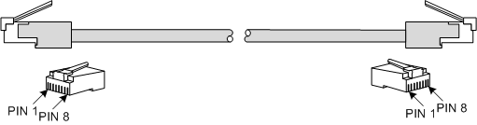

* + - 1. Technical specifications

The Ethernet cables are divided into two types:

* Straight-through cable: used to connect devices of different type, such as between a PC and a switch, or between a switch and a router
* Crossover cable: used to connect devices of the same type, such as between PCs, between switches, between routers, or between a PC and a router (they are of the same type)

Table 6-3 lists wiring of EIA/TIA 568A and EIA/TIA 568B standards.

Wiring of EIA/TIA 568A and EIA/TIA 568B standards

| Connector (RJ45) | EIA/TIA 568A | EIA/TIA 568B |
| --- | --- | --- |
| PIN 1 | White/Green | White/Orange |
| PIN 2 | Green | Orange |
| PIN 3 | White/Orange | White/Green |
| PIN 4 | Blue | Blue |
| PIN 5 | White/Blue | White/Blue |
| PIN 6 | Orange | Green |
| PIN 7 | White/Brown | White/Brown |
| PIN 8 | Brown | Brown |

Both two RJ45 connectors of the 10/100/1000 Mbit/s straight-through cable follow EIA/TIA568B standard wiring.

Figure 6-3 shows wiring of the 10/100/1000 Mbit/s straight-through cable.

Wiring of 10/100/1000 Mbit/s straight-through cable

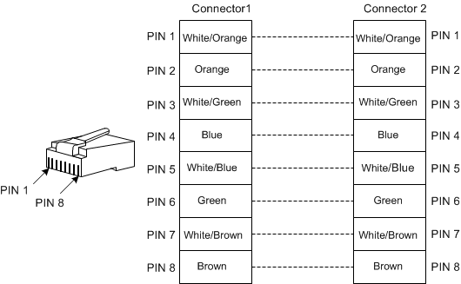

Figure 6-4 shows wiring of the 100 Mbit/s crossover cable.

Wiring of 100 Mbit/s crossover cable

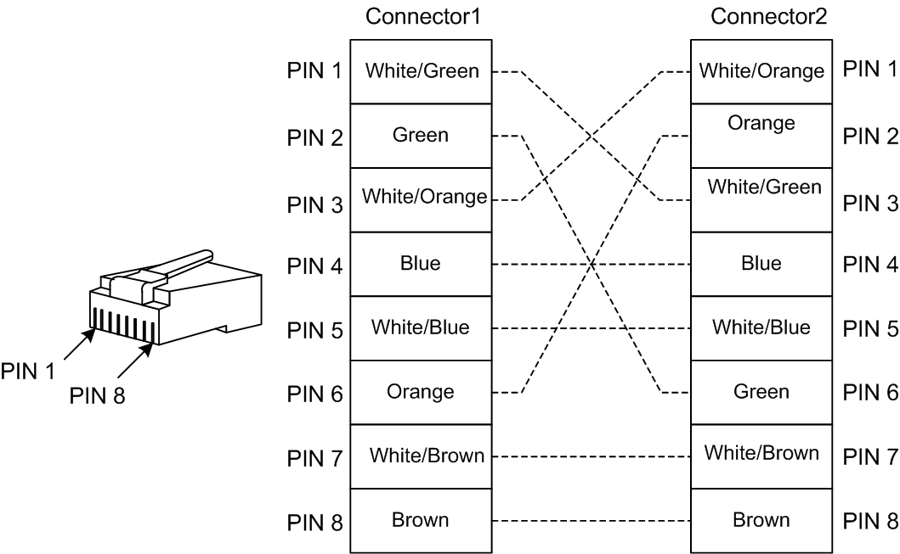

Figure 6-5 shows wiring of 1000 Mbit/s crossover cable.

Wiring of 1000 Mbit/s crossover cable

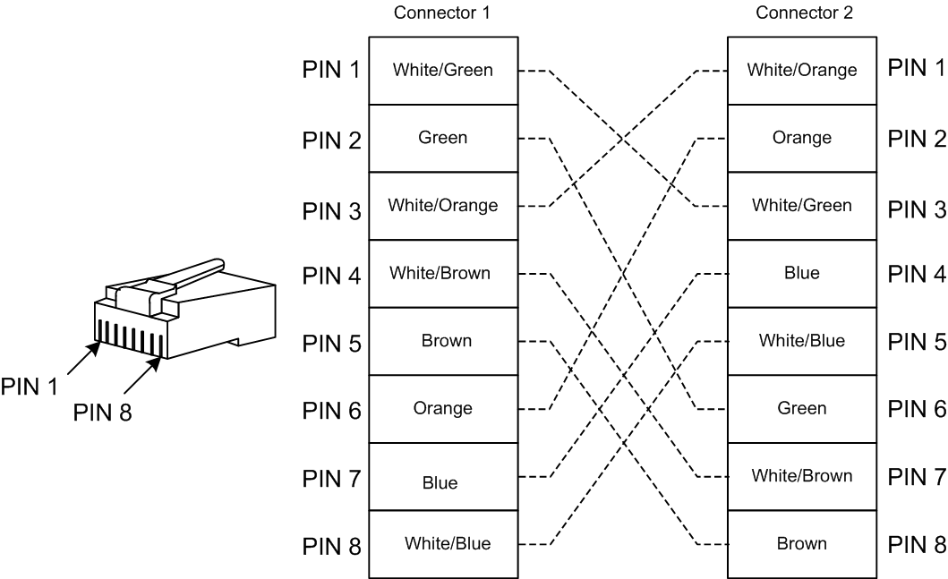

* + - 1. Technical specifications

Table 6-4 lists technical specifications of the Ethernet cable.

Technical specifications of Ethernet cable

| Parameter | Description |
| --- | --- |
| Name | CBL-ETH-RJ45/RJ45-D |
| Connector | RJ45 crystal header |
| Model | Cat 5 or better UTP (UTP-5 or UTP-5e) or Cat 5e STP cable |
| Number of cores | 8 |
| Length | The letter D is the length, which can be customized. For example, if the customer requires 2-meter cables, you can name it CBL-ETH-RJ45/RJ45-2m. |

### Ground cable

* + - 1. Introduction

The ground cable is used to connect the ISCOM2608G series switch to the ground.

* + - 1. Appearance

The ground cable is composed of ground terminals and the coaxial cable. The ground terminal is usually an OT non-insulated terminal. The coaxial cable is a yellow/green copper soft flame-retardant conducting wire. Figure 6-6 and Figure 6-7 show the ground cable and OT terminal.

Ground cable

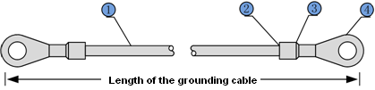

| 1 | Conducting wire | 2 | Stripped end (connected to the OT terminal) |
| --- | --- | --- | --- |
| 3 | Insulating sheath | 4 | OT terminal |

OT terminal

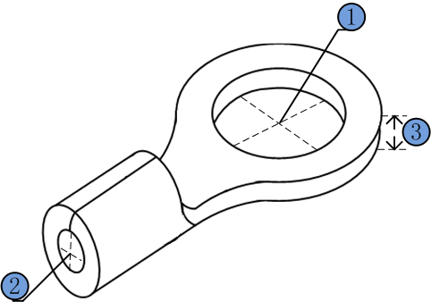

| 1 | Inner diameter of soldering lug | 2 | Inner diameter of sheath | 3 | Thickness of soldering terminal |
| --- | --- | --- | --- | --- | --- |

* + - 1. Technical specifications

Table 6-5 lists technical specifications of the ground cable.

Technical specifications of ground cable

| Parameter | Description |
| --- | --- |
| Model (recommended) | PIL-ground cable-Φ4-1m. |
| Conducting wire | Yellow/Green multi-strand copper-core conducting wire (1.25 mm2) |
| Model | Protective ground round pressed terminal (M4) |
| Cross-sectional area of the conducting wire | 16–15AWG (1.2–1.5 mm2) |
| Length | 1 m |

说明: Note.png

The ground cable cannot be longer than 30 m and should be as short as possible; otherwise, a ground bar should be used.

### DC power cable

* + - 1. Introduction

The DC power cable transmits -48 VDC power to the power interface on the ISCOM2608G series switch, and supplies power for the whole device.

* + - 1. Appearance

A DC power cable is composed of DC connectors and conducting wire, as shown in Figure 6-8.

DC power cable



* + - 1. Technical specifications

Table 6-6 lists technical specifications of the DC power cable.

Technical specifications of DC power cable

| Parameter | Description |
| --- | --- |
| Name | POL-DC (2 cores)-stripped wire/U-type terminal-0.75 mm2-1.5 m/RoHS |
| Connector | U-type terminal (flame-retardant tube) |
| Cable | * 2-core PVC-sheathed cord * 2 × 0.75mm2 60227 IEC 53 (RVV) * The stripped wire is equipped with a flame-retardant tube. * +Vin positive wire: brown * -Vin negative wire: blue |
| Rated voltage (V) | 300/500 |
| Insulation and withstanding voltage (sheathe of cable core pairs) | 2000 VAC, 5min |
| Insulation and withstanding voltage (cable core) | 1500 VAC, 5min |
| Certification | CCC |
| RoHS | Compliant |

### AC power cable

* + - 1. Introduction

The AC power cable transmits 220 VAC power to the power interface on the ISCOM2608G series switch, and supplies power for the whole device.

The AC power cables used by the ISCOM2608G series switch vary with countries or regions, as lists in Table 6-7.

AC power cables

| Regional standard | Cable |
| --- | --- |
| Europe | POL-AC-European-3-pin/C13 connector-0.75mm2-1.5m/RoHS |
| America | POL-AC-American-3-pin/C13 connector-18AWG-1.5m/RoHS |

* + - 1. Appearance

The AC power cable which meets European standard is composed of the European French mode 3-pin plug and C13 connector, as shown in Figure 6-9.

European AC power cable

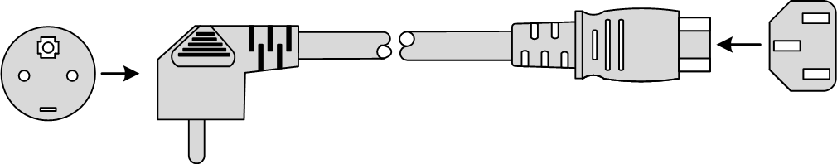

The AC power cable which meets American standard is composed of the American 3-pin plug and C13 connector, as shown in Figure 6-10.

American AC power cable

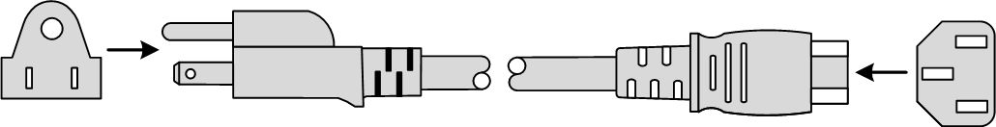

* + - 1. Technical specifications

Table 6-8 lists technical specifications of the European AC power cable.

Technical specifications of European AC power cable

| Parameter | | Description |
| --- | --- | --- |
| Name | | POL-AC-European-3-pin/C13 connector-0.75mm2-1.5m/RoHS |
| Color | Outer | Black (PVC insulation layer) |
| Inner | Blue (N), brown (L), and yellow/green stripe (E) |
| Connector 1 | | IEC60320-C13 connector |
| Connector 2 | | European 3-pin plug |
| Inner conductor cross-sectional area | | 3×0.75 mm2 |
| Length | | 1.5 m |

Table 6-9 lists technical specifications of the American AC power cable.

Technical specifications of American AC power cable

| Parameter | | Description |
| --- | --- | --- |
| Name | | American 3-pin-10A/250V-1.5m/RoHS |
| Color | Outer | Black (PVC insulation layer) |
| Inner | White (N), black (L), and green (E) |
| Connector 1 | | IEC60320-C13 connector |
| Connector 2 | | American 3-pin plug NEMA5-15 |
| Inner conductor wire gauge | | 18 AWG |
| Length | | 1.5 m |

### RJ45 Console cable

* + - 1. Introduction

With a Console cable, you can log in to the ISCOM2608G series switch through the Console interface, and then debug and maintain it through a PC.

The connectors at the two ends of the Console cable are as below:

* RJ45 connector: connected to the Console interface on the ISCOM2608G series switch
* DB9 female connector: connected to the Console interface on the PC
  + - 1. Appearance

Figure 6-11 shows the RJ45 Console cable.

RJ45 Console cable

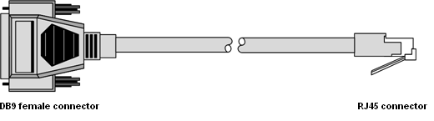

* + - 1. Wiring

Table 6-10 lists wiring of the RJ45 Console interface.

Wiring of RJ45 Console interface

| PIN | PIN definition | |
| --- | --- | --- |
| Switch (RJ45) | Console (DB9) |
| PIN 1 | NC | DCD |
| PIN 2 | NC | RxD |
| PIN 3 | RxD | TxD |
| PIN 4 | GND | DTR |
| PIN 5 | GND | GND |
| PIN 6 | TxD | DSR |
| PIN 7 | NC | RTS |
| PIN 8 | NC | CTS |
| PIN 9 | – | RI |

Figure 6-12 shows wiring between the DB9 female connector and the RJ45 Console interface on the ISCOM2608G series switch.

Wiring between DB9 female connector and RJ45 Console interface

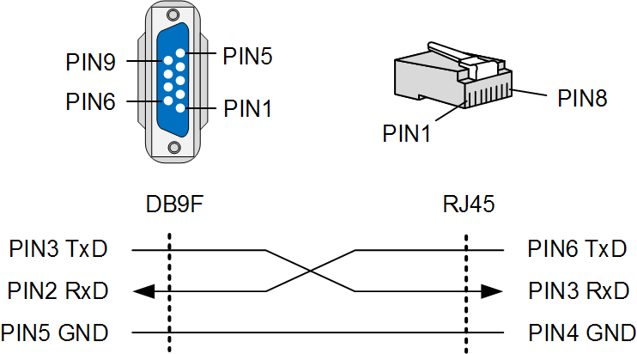

* + - 1. Technical specifications

Table 6-11 lists technical specifications of the RJ45 Console cable.

Technical specifications of RJ45 Console cable

| Parameter | Description |
| --- | --- |
| Name | CBL-RS232-DB9F/RJ45-2m |
| Color | White |
| Model | Cat 3 UTP cable |
| Connector | RJ45 connector and DB9 female connector |
| Number of cores | 8 |
| Length | 2 m |

## Terms

|  |  |
| --- | --- |
| **A** |  |
| Access Control List (ACL) | A series of ordered rules composed of permit | deny sentences. These rules are based on the source MAC address, destination MAC address, source IP address, destination IP address, interface ID, etc. The device decides to receive or refuse the packets based on these rules. |
| Auto-negotiation | The interface automatically chooses the rate and duplex mode according to the result of negotiation. The auto-negotiation process is: the interface adapts its rate and duplex mode to the highest performance according to the peer interface, that is, both ends of the link adopt the highest rate and duplex mode they both support after auto-negotiation. |
|  |  |
| **B** |  |
| Bracket | It is a component at the flank side of the device, used for installing the chassis into the rack. |
|  |  |
| **D** |  |
| Digital Subscriber Line Access Multiplexer (DSLAM) | It is a network device, often located in [telephone exchanges](https://en.wikipedia.org/wiki/Telephone_exchange), that connects multiple customer [digital subscriber line](https://en.wikipedia.org/wiki/Digital_subscriber_line) (DSL) interfaces to a high-speed digital communications channel using [multiplexing](https://en.wikipedia.org/wiki/Multiplexing) techniques. |
| Dynamic ARP Inspection (DAI) | A security feature that can be used to verify the ARP data packets in the network. With DAI, the administrator can intercept, record, and discard ARP packets with invalid MAC address/IP address to prevent common ARP attacks. |
| **E** |  |
| Ethernet Linear Protection Switching (ELPS) | It is an APS protocol, based on ITU-T G.8031 standard, used to protect the Ethernet link. It is an end-to-end protection technology, including two line protection modes: linear 1:1 protection switching and linear 1+1 protection switching. |
| Ethernet Ring Protection Switching (ERPS) | It is an APS protocol based on ITU-T G.8032 standard, which is a link-layer protocol specially used for the Ethernet ring. In normal conditions, it can avoid broadcast storm caused by the data loop on the Ethernet ring. When the link or device on the Ethernet ring fails, services can be quickly switched to the backup line to enable services to be recovered in time. |
|  |  |
| **F** |  |
| Frame | It is a data transmission unit, composed of several parts, each of which has different functions. |
| Full duplex | In a communication link, both parties can receive and send data concurrently. |
|  |  |
| **H** |  |
| Half duplex | In a communication link, both parties can receive or send data at a time. |
|  |  |
| **L** |  |
| Link Aggregation | With link aggregation, multiple physical Ethernet interfaces are combined to form a logical aggregation group. Multiple physical links in one aggregation group are taken as a logical link. Link aggregation helps share traffic among member interfaces in an aggregation group. In addition to effectively improving the reliability on links between devices, link aggregation can help gain greater bandwidth without upgrading hardware. |
| Link-state tracking | Link-state tracking provides an interface linkage scheme, extending the range of link backup. Through monitoring uplinks and synchronizing downlinks, faults of the upstream device can be transferred quickly to the downstream device, and primary/backup switching is triggered. In this way, it avoids traffic loss because the downstream device does not sense faults of the upstream link. |
| **M** |  |
| Multi-mode Fiber (MMF) | In this fiber, multi-mode optical signals are transmitted. |
|  |  |
| **P** |  |
| Protection Ground Wire | It is generally a yellow-and-green coaxial cable used for connecting the device to the ground. |
|  |  |
| **Q** |  |
| Quality of Service (QoS) | A network security mechanism, used to solve problems of network delay and congestion. When the network is overloaded or congested, QoS can ensure that packets of important services are not delayed or discarded and the network runs high efficiently. Depending on the specific system and service, it may relate to jitter, delay, packet loss ratio, bit error ratio, and signal-to-noise ratio. |
| QinQ | 802.1Q in 802.1Q (QinQ), also called Stacked VLAN or Double VLAN, is extended from 802.1Q and defined by IEEE 802.1ad recommendation. This VLAN feature allows the equipment to add a VLAN tag to a tagged packet. The implementation of QinQ is to add a public VLAN tag to a packet with a private VLAN tag, making the packet encapsulated with two layers of VLAN tags. The packet is forwarded over the ISP's backbone network based on the public VLAN tag and the private VLAN tag is transmitted as the data part of the packet. In this way, the QinQ feature enables the transmission of the private VLANs to the peer end transparently. There are two QinQ types: basic QinQ and selective QinQ. |
|  |  |
| **R** |  |
| RS232 | It is an Asynchronous Transfer Mode (ATM), which does not contain hand-shaking signals. It can carry on point-to-point communication with RS232 and RS422 of other stations, featuring transparent transmission, with a maximum rate of 19.2 Kbit/s. Generally, the form of RS232 interface is DB9 or DB25. |
| Remote Authentication Dial In User Service (RADIUS) | RADIUS refers to a protocol used to authenticate and account users in the network. RADIUS works in client/server mode. The RADIUS server is responsible for receiving users' connection requests, authenticating users, and replying configurations required by all clients to provide services for users. |
|  |  |
| **S** |  |
| Single-mode Fiber (SMF) | In this fiber, single-mode optical signals are transmitted. |
|  |  |
| **V** |  |
| Virtual Local Area Network (VLAN) | VLAN is a protocol proposed to solve broadcast and security issues for Ethernet. It divides devices in a LAN into different segments logically rather than physically, thus implementing multiple virtual work groups which are based on Layer 2 isolation and do not affect each other. |

## Acronyms and abbreviations

| **A** |  |
| --- | --- |
| ACL | Access Control List |
| AN | Access Node |
| APS | Automatic Protection Switching |
| ARP | Address Resolution Protocol |
|  |  |
| **C** |  |
| CFM | Connectivity Fault Management |
| CoS | Class of Service |
| CPU | Central Processing Unit |
| CSMA/CD | Carrier Sense Multiple Access/Collision Detection |
|  |  |
| **D** |  |
| DAI | Dynamic ARP Inspection |
| DFB | Distributed Feed Back |
| DiffServ | Differentiated Service |
| DRR | Deficit Round Robin |
| DS | Differentiated Services |
| DSCP | Differentiated Services Code Point |
| DSL | Digital Subscriber Line |
| DSLAM | Digital Subscriber Line Access Multiplexer |
|  |  |
| **E** |  |
| EDD | Ethernet Demarcation Device |
| EFM | Ethernet in the First Mile |
| ELPS | Ethernet Linear Protection Switching |
| EMC | Electro Magnetic Compatibility |
| ERPS | Ethernet Ring Protection Switching |
| ETS | European Telecommunications Standards |
| ETSI | European Telecommunications Standards Institute |
|  |  |
| **I** |  |
| IGMP | Internet Group Management Protocol |
|  |  |
| **L** |  |
| LLDP | Link Layer Discovery Protocol |
| LOS | Loss of Signal |
| **M** |  |
| MEF | Metro Ethernet Forum |
| MTBF | Mean Time Between Failure |
| MVR | Multicast VLAN Registration |
|  |  |
| **N** |  |
| NGN | Next Generation Network |
| NNM | Network Node Management |
| NView NNM | NView Network Node Management |
|  |  |
| **P** |  |
| PHB | Per-Hop Behavior |
| PPPoE | PPP over Ethernet |
| PVC | Permanent Virtual Circuit |
|  |  |
| **R** |  |
| RADIUS | Remote Authentication Dial In User Service |
| RH | Relative Humidity |
| RMON | Remote Network Monitoring |
|  |  |
| **S** |  |
| SLA | Service Level Agreement |
| SP | Strict-Priority |
| SSHv2 | Secure Shell v2 |
| STP | Spanning Tree Protocol |
|  |  |
| **T** |  |
| TACACS+ | Terminal Access Controller Access Control System |
| TFTP | Trivial File Transfer Protocol |
|  |  |
| **U** |  |
| UART | Universal Asynchronous Receiver/Transmitter |
| UL | Underwriter Laboratories |
| UNI | User Network Interface |
|  |  |
| **W** |  |
| WRR | Weight Round Robin |



**Address: Raisecom Building, No. 11, East Area, No. 10 Block, East Xibeiwang Road, Haidian District, Beijing, P.R.China Postal code: 100094 Tel: +86-10-82883305**

**Fax: 8610-82883056 http://www.raisecom.com Email: export@raisecom.com**

**Address: Building2, No.28 of theShangdi6thStreet, Haidian District, Beijing, P.R.China.**

**Postcode: 100085 Tel: +86-10-82884499**

**Fax: 8610-82885200 http://www.raisecom.com Email: help@raisecom.com**